2026 SCHEDULED TRAINING INTAKE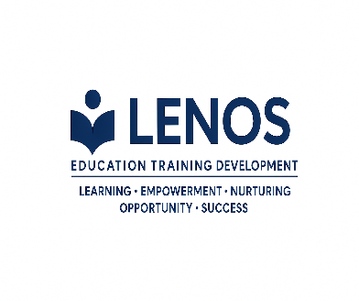
Skills Programme title | Skills Programme ID Number | NQF Level | Credits | Days | Intake dates | Delivery Mode
Conflict Management | SP-210409 | 5 | 8 | 10 (3 classroom; 7 Practical) | 28-30 April 2026  11-13 May 2026  17-19 August 2026  21-23 September 2026 | Face-to-Face
New Venture Creation | SP-210401 | 2 | 32 | 15 (5 classroom; 10 Practical) | 04-08 May 2026  01-05 June 2026  24-28 August 2026  05-09 October 2026 | Face-to-Face
Workplace Essential Skills | SP-211009 | 4 | 20 | 25 (classroom; 17 Practical | 18- 27 May 2026  31 Aug- 04 Sept 2026  14-23 October 2026  18-27 November 2026 | Face-to-Face
Project Management Facilitator (Project Management for non-project managers) | SP-250710 | 6 | 60 | 75 (50 classroom; 25 Practical)- 15 Weeks | 08 June- 14 August 2026 | Face-to-Face

